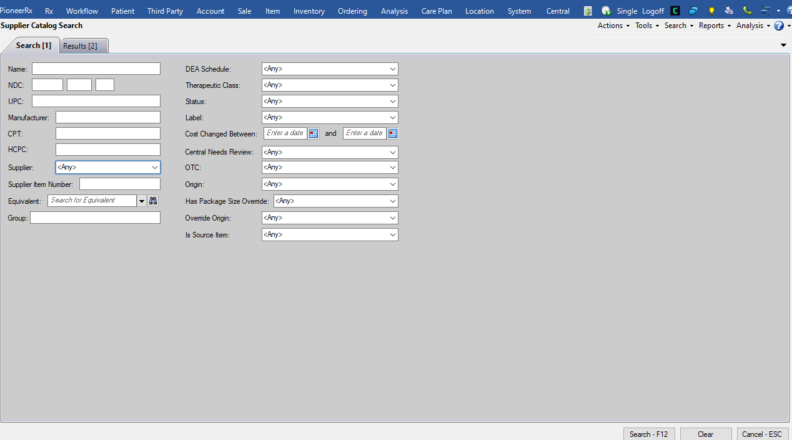

**STEPS ->** Go to Ordering -> Click on binoculars next to Catalog Item -> Supplier Catalog Search page

**TO DO ->**need to add here is a (Supplier Category) dropdown. The dropdown should go underneath Group:, selected option should be <Any>.

**PROCEDURE->** [General].[CategoryGetListByCategoryScopeID]

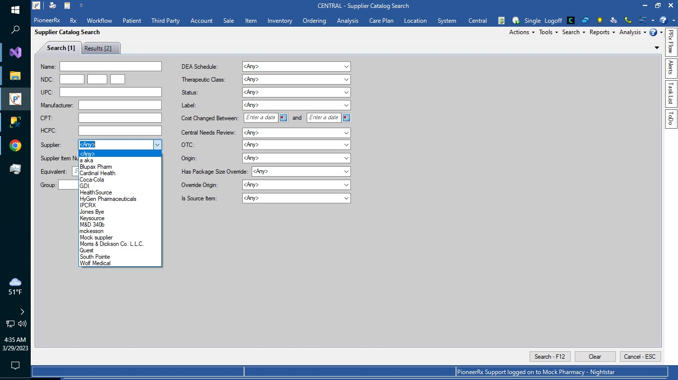

* When a user selects a value other than <Any> from the Supplier Category dropdown, CategoryID should be retrieved and
* It should be injected in the search WHERE clause for the final catalog search execution.
* SQL-> You are most likely going to need to update the view [Supplier].[SupplierCatalogItemSearchList] so it LEFT JOINs into Supplier.Category table.
* For testing purposes, you can do the following:

Go to Ordering -> Supplier -> Pull up any Supplier that is Active (Status is in the bottom left) -> Go to Categories tab -> Select a category -> Save

Go to Supplier Catalog Search -> Select that category that you just checked on the Supplier -> Search -> Make sure catalog items show up for that Supplier (there might be catalog items showing up for other suppliers with that same category checked)